1. **Install JDK:**

Follow this link to download JDK: http://www.oracle.com/technetwork/java/javase/downloads/index.html  
Install JDK

Double click on file jdk-7u4-windows-i586-p.exe (another file name if you choose another install packet) for installation

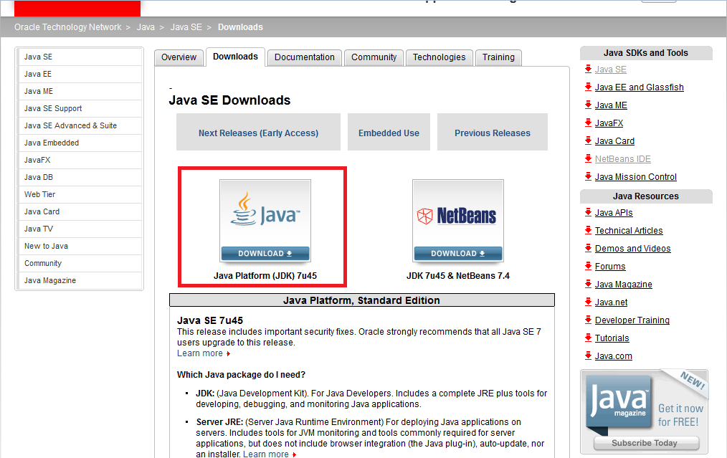

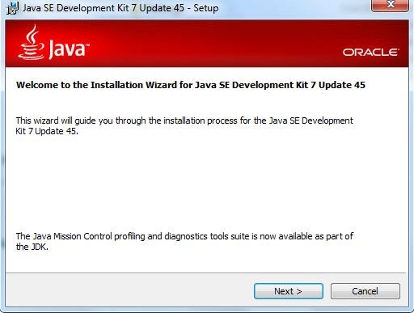  
- Welcome to the Installation JDK  
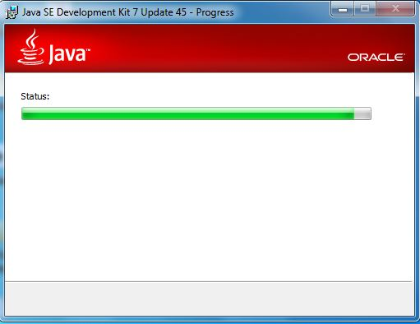

wait several minutes...  
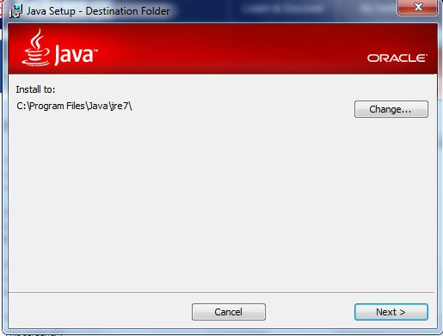

then, install JRE (Automatically), choose the same folder...  
  
after installation, the capacity was occupied are 250MB  
* Setup variable environment:  
- Go to this path: start->control panel->system(Windows Vista: Control Panel -> System -> Advanced system settings)  
- Choose Advanced tab, click "Environment Variables" to open "Environment Variables" dialog, click "New", set JAVA_HOME point to Java install folder, in this case is D:\Java

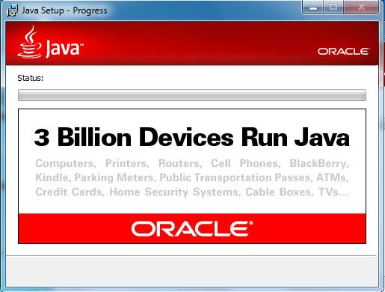  
- Java Setup Process  
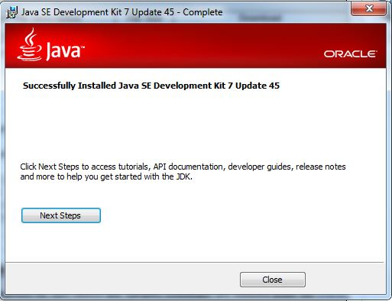

Success

1. **Install SQL:**

* Follow this link to download Microsoft SQL Server:

<http://www.microsoft.com/en-us/download/details.aspx?id=7593>

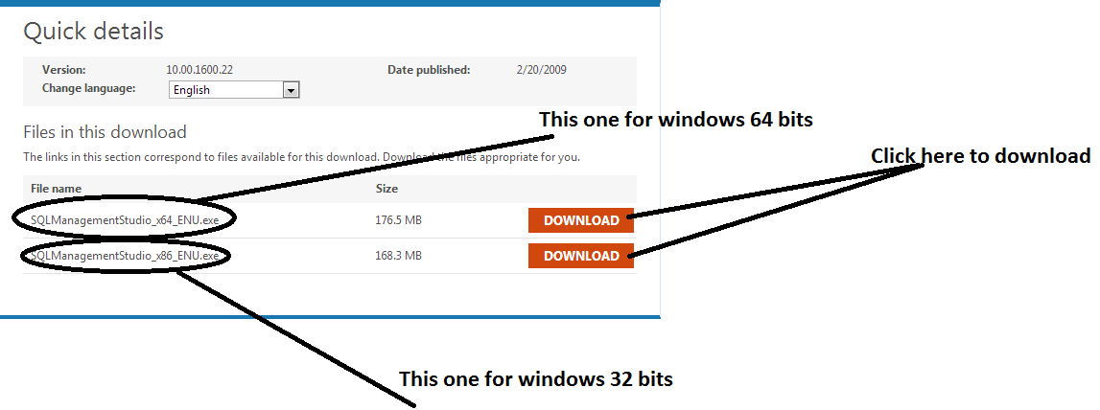- After download, double click on file .exe for installation. Follow these steps:

+ Step1 : choose Installation like the below picture. Then,choose New SQL Server stand-alone installation or add features to an existing installation

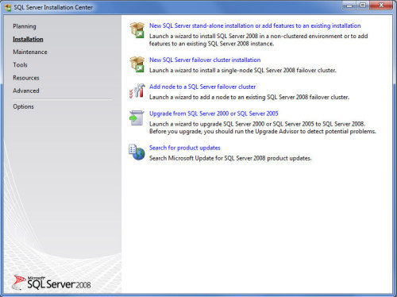

+ Step 2 : At Setup Support Rules screen click OK

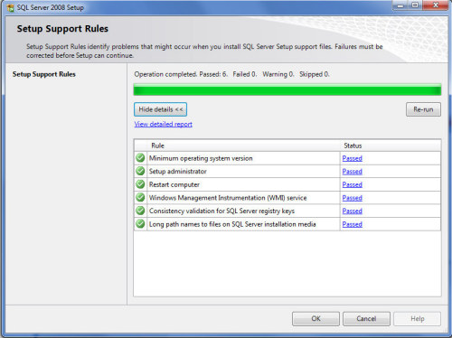

+ Step 3 : At Product Key screen, click Next tocontinue

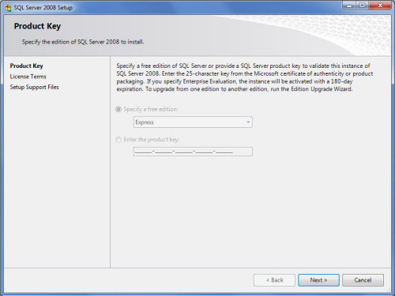

+ Step4 : At License Term screen, choose "I accept the licence terms", and click "Next"

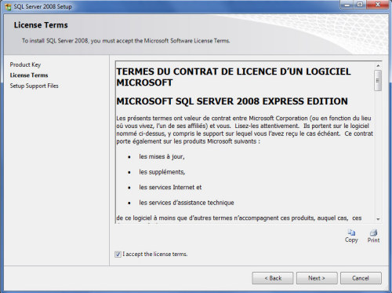

+ Step5 :At setup support files screenclick "install" to continue.

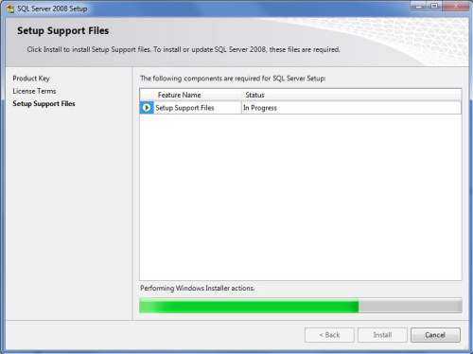

+ Step6 :At Setup Support Rules screen, click Next to continue.

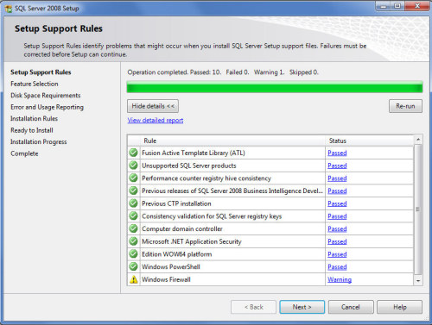

+ Step7 :At features selection screen, clickSellect All to select all feature, then, click "Next".

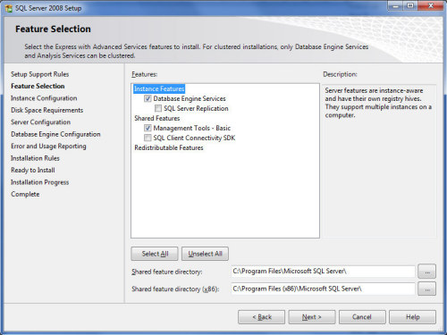

+ Step8 :At instance Configuratio screen, there are two option : choose like the picture below, then,click Next to continue....

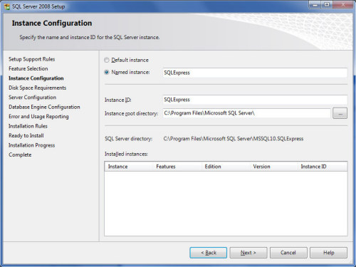

+ Step 9 :Click Next to continue.

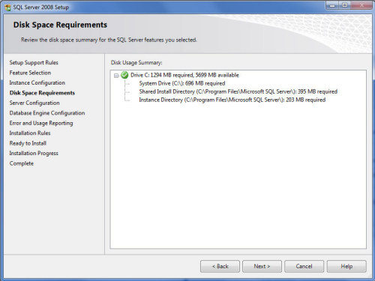

+ Step10 :choose Account Name columnand type this name in it: “NT AUTHORITY\NETWORK”, then, click next to continue.

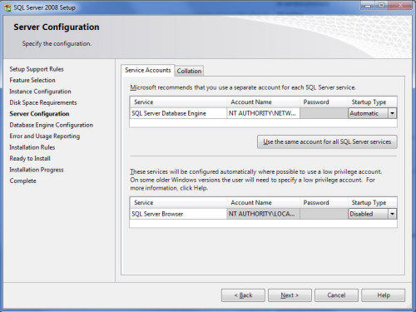

+ Step11 : AtDatabase Engine Configuration screen, choose Account Provisioning tab, then, choose“Windows Authotication Mode" or "Mixed Mode".  
If you choosed "Windows Authotication Mode",you didn’t have to enter your PassWord, to simple you should choose "Windows Authotication Mode".  
If you choosed "Mixed Mode" you had to enter yourPassWord.  
Finally, click "Add Current User" and then click Next to continue.

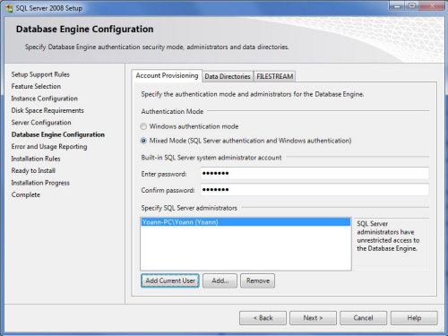

+ Step12 :Click Next to continue

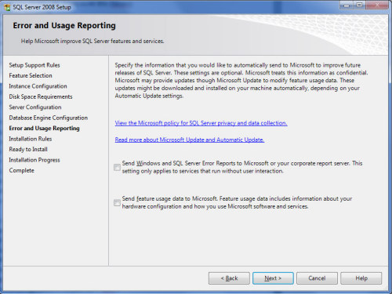

+ Step13 :click Next to continue

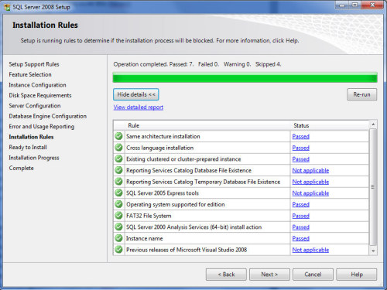

+ Step14 :click "Install" to perform installation, the installation is take about 3 minutes ...

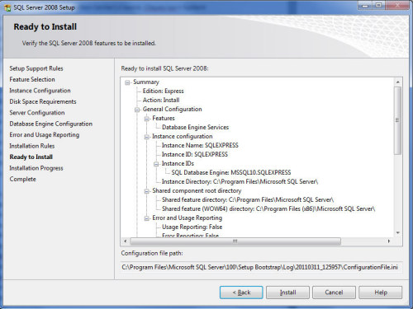

+ Step15 :click Next to complete installation

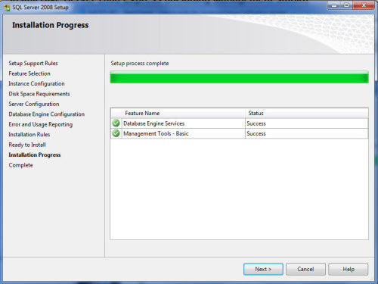

1. **Install Apache Tomcat 7.0.47**
2. Follow this link to download Apache Tomcat:

<http://tomcat.apache.org/download-70.cgi>

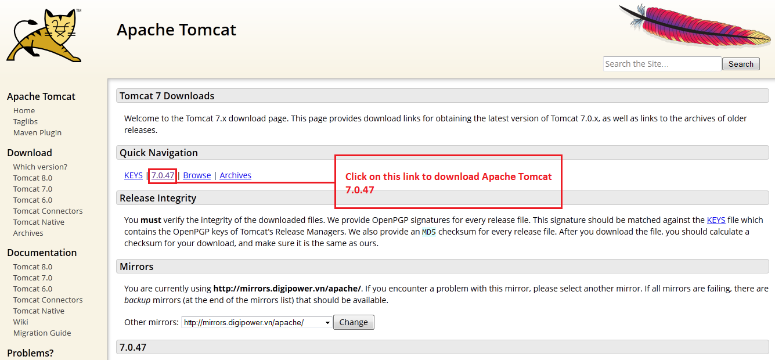

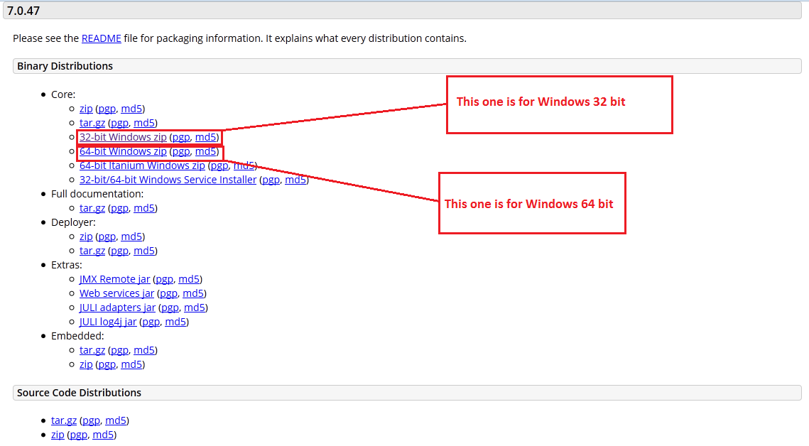

1. Install and Use ApacheTomcat 7.0.47:

* When download is success, copy and paste file “apache-tomcat-7.0.47-windows-x86.zip” to disk (D:) and extract this file:

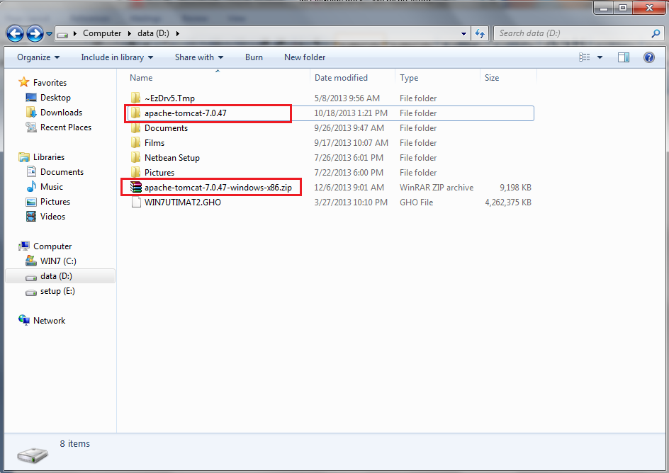

* Open Netbeans IDE 7.2.1, choose Tools/Servers:

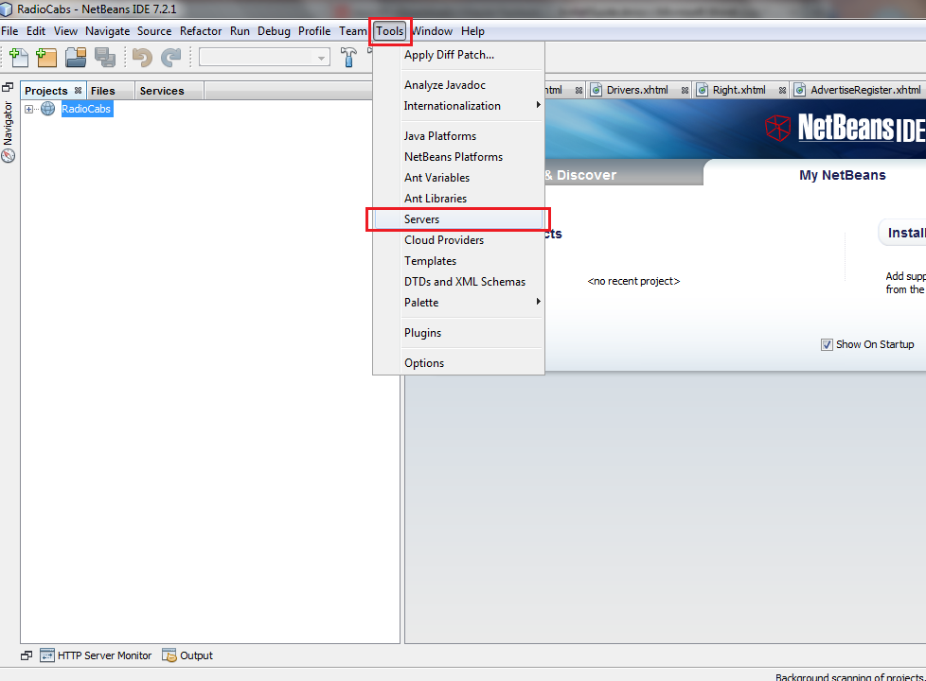

* Click on button “Add Server...”:

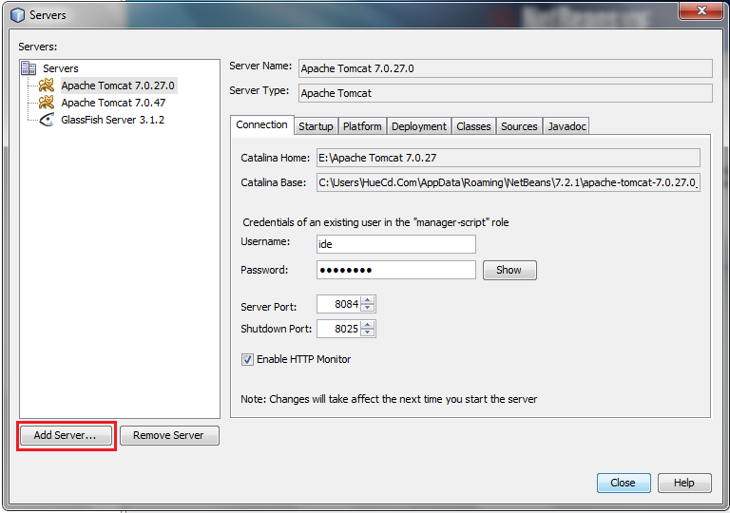

* Choose server Apache Tomcat, then click Next:

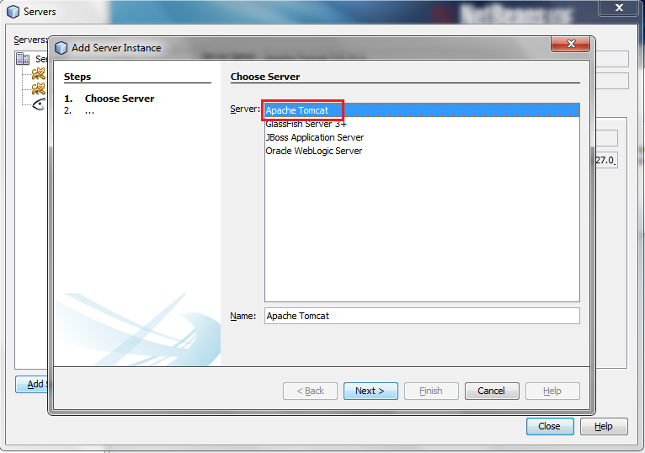

* Choose server location, follow (D:/apache-tomcat-7.0.47):

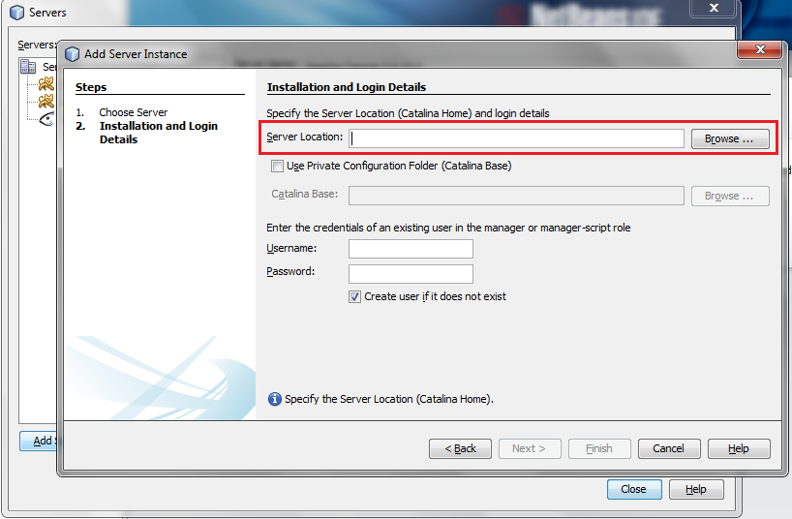

* Then click on Open button:

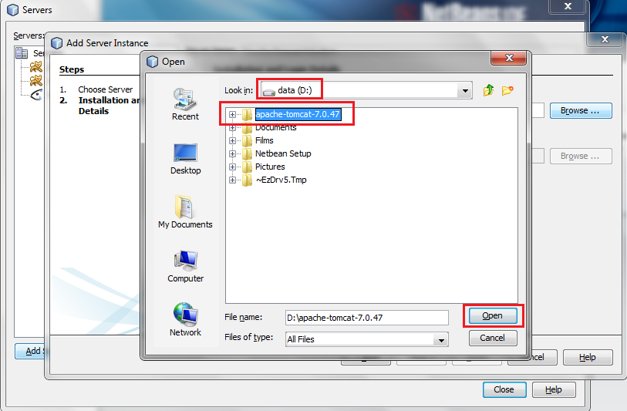

* Fill in Username and Password textbox: admin/admin and click Finish.

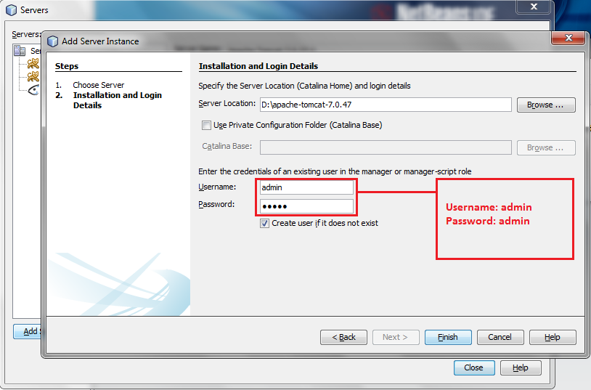

* Click Close:

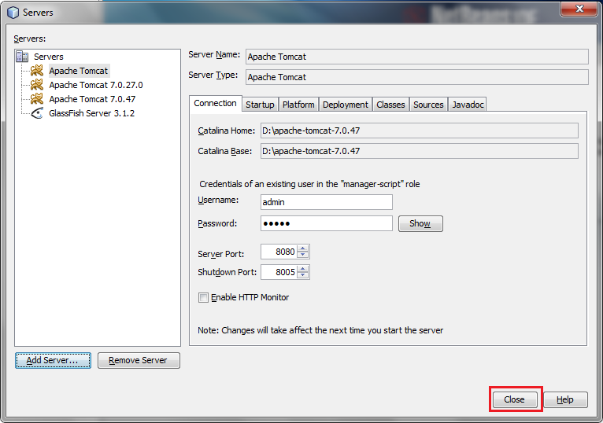

* Right-click on our project, choose Properties:

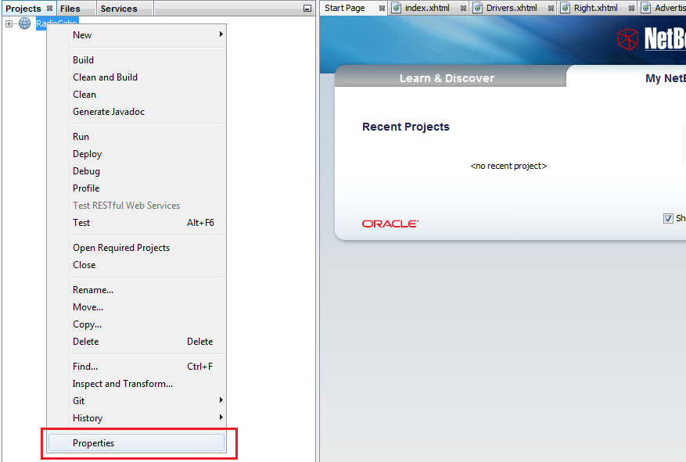

* Choose Run:

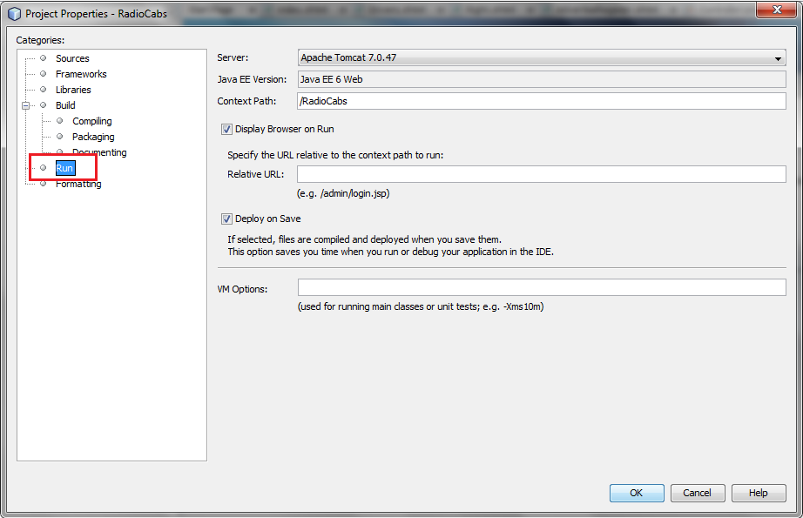

* Then, choose the server you have just add at previous steps, then click OK.

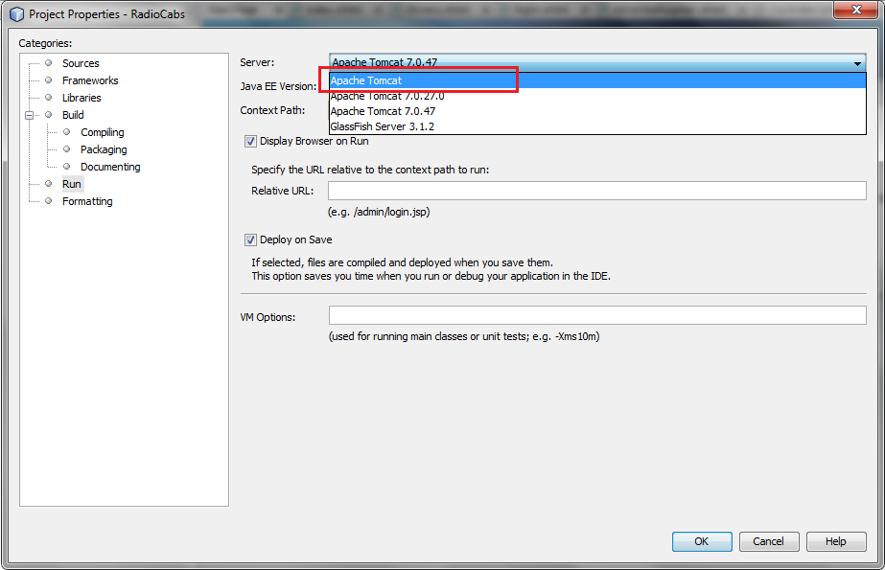

* Wait a few minutes to save the data:

